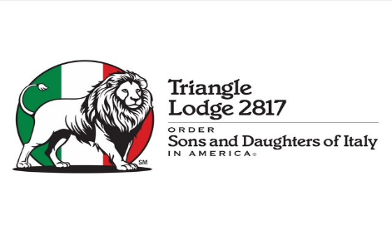
Triangle Sons and Daughters of Italy - Lodge 2817
2026-2027 SCHOLARSHIP APPLICATION FORM

Name: Name

Address: Street address

City, State, Zip: City, State, Zip

Cell Phone: Cell phone number

Email: Email address

Please identify your Italian lineage/Culture (Check All That Apply):

☐ Mother’s family ☐ Father’s family

Please give the Italian surnames in your lineage if known:
Surnames

☐ REQUIRED: Descendant of: Lodge Member’s Name

Note: Your TSDIA Descendant must be a formal TSDIA Lodge Member in good standing as of December 31, 2025 or prior to that date.

Are you currently a USA Citizen or Green Card Holder (Indicate Yes or No): Yes or No

Are you currently a High School Senior (Indicate Yes or No): Yes or No

Will you be a full-time Freshman or 1st Year full-time student in post-secondary education at a college or technical school in Fall 2026 (Indicate Yes or No):Yes or No

School planning to attend: School name

Committee Use Only:

☐ WORD Package Received with Application and Essay
☐ Resume Received (Separate Document Submitted)
☐ Most Recent Available Transcript Received (Separate Document Received)
☐ Standardized Test Scores (Optional Separate Document Received)

NAME: ______________________________________

TRIANGLE LODGE 2817 SCHOLARSHIP ESSAY & SUBMISSION INSTRUCTIONS

Starting on the next full page, please type a 500 - 1000 word original essay which addresses the topics below.

- How did you develop an appreciation for Italian and/or Italian American culture?

- How do you demonstrate your pride and support for Italian and/or Italian American culture? Examples may include classes, clubs, family events, trips, community organizations and activities.

- Describe your leadership experiences in any type of setting or organizations.

- Describe your involvement in any type of community and/or philanthropic activities.

- Describe your paid or unpaid work experiences.

- Highlight your academic achievements. Examples include GPA, Honor Societies, Class Rank, and Academic Awards.

SUBMISSION INSTRUCTIONS

Rename this WORD Document to “Your Last Name Scholarship Application” (example: Rossi Scholarship Application)

Email all documents (Required WORD Application & Essay, Resume, Most Recent Transcript, and Optional Standardized Test Scores) to Elisa Rossi at elisa.rossi@yahoo.com

Submission deadline is April 7, 2026

NAME: _______________________________________________________________

Triangle Lodge 2817 Scholarship Essay

