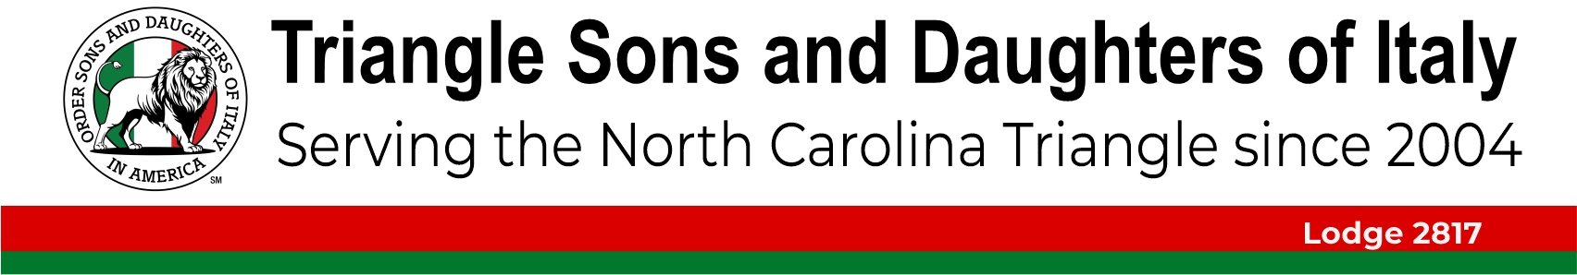
Il Giornale di TSDIA Luglio, 2025

 Follow us on Facebook at “Triangle Sons & Daughters of Italy”
 And on our YouTube Channel youtube.com/@tsdoiyoutube7441

Please note that we take photos and videos at our events. If you do not want your image to appear on either Facebook or YouTube, you must tell the photographer at the time.
Il Giornale di TSDIA
Editor Nick Verna
Send comments or suggested materials to nickverna14@gmail.com

Table of Contents
TSDIA Calendar of Events 2
July Birthdays 2
Letter from the President 2
Annual Family Picnic 3
Cape Fear Fundraiser 5
SICILY - Land of Love and Strife – August 3rd 6
The Charit Races of Ancient Rome: It’s Italy’s Palio di Siena! 6
Durham Bulls 2025 7
New Members 8
Eating in Italy like a local citizen: tips for foreigners 9
Castel Gandolfo: the Pope’s summer retreat 10
Thanks to Netflix's 'Nonnas,' Italian grandmas are having their moment 11
Cala Goloritzé, the best beach in the world is in Sardinia 12
Seada 12
Pasta Salad with Sun-Dried Tomatoes and Artichokes 13
Pasta alla Norcina 14



TSDIA Calendar of Events
Jul 21 – Conversational Italian
July 24 – Scopa
Aug 3 – Sicily Land of Love and Strife
Aug 9 – Palio de Siena
Aug – Scopa
Aug 25 – Conversational Italian
Sep 20 – Festa Italiana
Sep 29 – Conversational Italian
Oct 11 – Italian American Heritage Celebration
Dec 6 – Christmas Party
Dec 6 – Autism & Disability Party
NOTE: members need to send Don Cimorelli an email to be included on the Conversational Italian distribution list for monthly meetups.


July Birthdays
Mike Frieda (1), Diane Goodman (3), Ann DeLorenze (5), David Gifford (5), Joanne Tucci (9), Pat Corpora (18), Paul Caci (11), Becky Stinnett (11), Ralph Iovino (12), Susan Schiro (14), Ethan Biamonte (14), Melanie Elliott (14), Peter Galluzzo (15), Jennifer Gaston (15), Anne-Marie Hennessy (15), Cheryl Cavalieri (18), Frank DeMaria (20), Andrian Schaller (20), Carol Blackford (21), Marisa Kilbrith (22), Mary Muth (22), Lauren Scheetz (23), William Ward (23), Elaina DeAngelo (25), Stephanie Elliott (31).

Letter from the President
Dear Members:
I hope that you have found a cool place to chill out as temperatures have been soaring quite high.
Our membership renewal process will begin in July. This renewal process applies to current members whose membership will expire on August 31, 2025. You will receive an email in July with instructions on how to renew your membership online. Your new membership period will run from September 1, 2025 - August 31, 2026. We do have some members whose membership is already extended to August 31, 2026, and those members will not receive a renewal invoice.
We have two great events planned for August. Below is the information and I highly encourage you to register. These are very interesting programs on Sicily and the Palio di Siena horse races in Italy.
SICILY FILM & PRESENTATION ON SUNDAY, AUGUST 3RD AT 1:00 PM
The Triangle Son and Daughters of Italy present “Sicily: Land of Love & Strife,” a feature-length documentary created to change public perception of Sicily. The film will be shown at the Triangle Cinemas in Raleigh on Sunday, August 3 at 1:00 pm. Tickets are $10 each. The movie will be hosted by its author and director, Mark Spano, who will answer questions about the movie and Sicily after the documentary. All attendees will receive biscotti to bring home.
To purchase tickets, go to https://square.link/u/WQ6HoH2g
PALIO DI SIENA ON SATURDAY, AUGUST 9TH AT 9:00 AM
CRAZIER THAN THE KENTUCKY DERBY AND WILDER THAN THE CHARIOTT RACES OF ANCIENT ROME, IT IS ITALY's PALIO di SIENA!
Saturday, August 9, 2025, 9:00 AM
Triangle Cinema, 9500 Forum Dr, Raleigh, NC 27615
FREE EVENT FOR MEMBERS AND GUESTS WITH BREAKFAST INCLUDED. REGISTER GUESTS WITH AN INTEREST IN EXPLORING TSDIA MEMBERSHIP.

It’s time to whet your appetite and introduce you to the coming of our 2nd Annual Siena Palio horse race. If you’re looking for a totally unique, authentic, and breathtaking cultural experience, you just found it! The Triangle Sons and Daughters of Italy is presenting “The Palio of Siena” on Saturday, August 9th at 9:00 am. You’ll enjoy the Palio, which is the most important event of the Sienese town (Tuscany Region) that dates back to the 13th century.
You’ll be joining the Sienese people as they demonstrate their flag throwers, trumpeters, and drummers all dressed in their armor and medieval costumes parading around the Piazza del Campo. They’ll be surrounded by more than 60,000 cheering Contrada (neighborhood) supporters in preparation of the exhilarating and uncontrollable horse race, The Palio. It’s not just a race, but a passion. It’s a chaotic medieval-style horse race that takes place in the Piazza del Campo, Siena’s famous central square. It’s an extremely emotional event that brings the Sienese to tears of joy and despair, despite the race’s macho nature. Absolutely nothing matters more to the Sienese than winning this race for their neighborhood.
Please click on the SignUp Genius Link below to formally register for this event.
https://www.signupgenius.com/go/9040A4DAAAF2EA6FE3-51000253-future#/
Don Cimorelli - TSDIA President

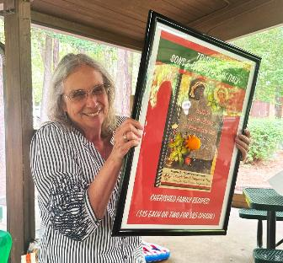
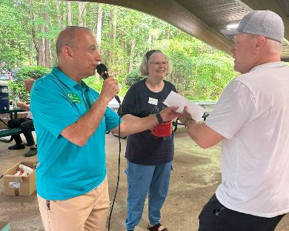
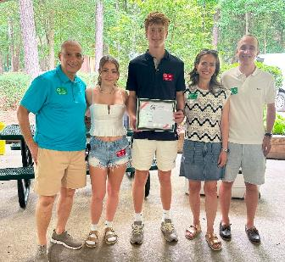
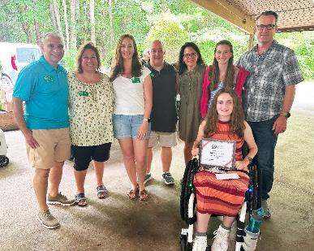
Annual Family Picnic
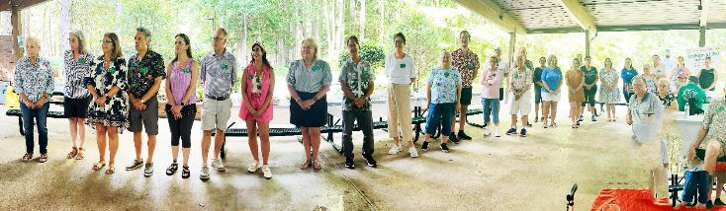
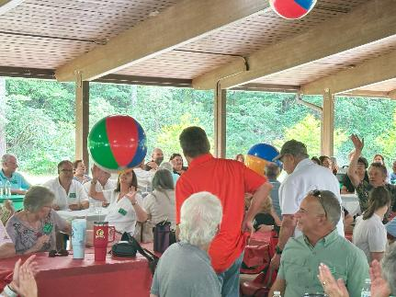
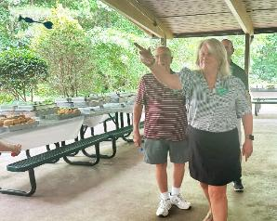
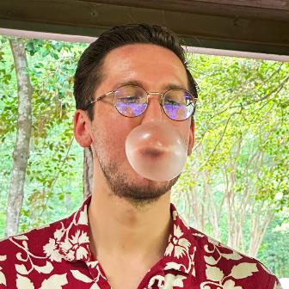
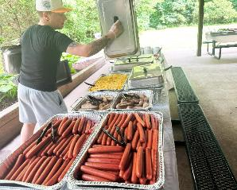
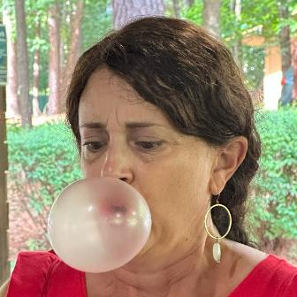
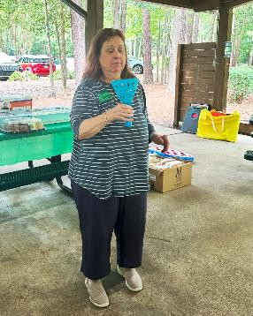

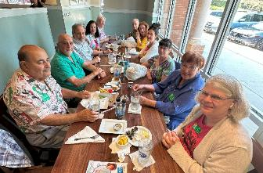
Cape Fear Fundraiser
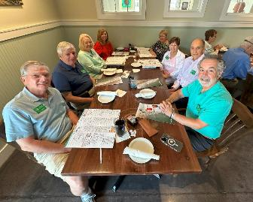
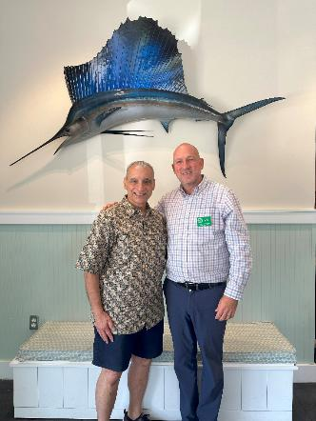
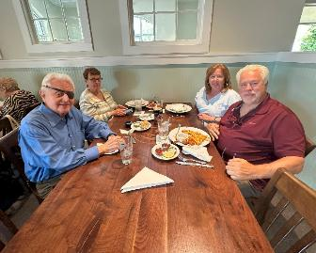
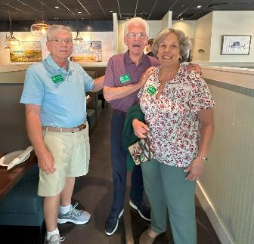
Special thanks to Cape Fear Seafood restaurant for donating $1,400 from their lunch proceeds at their new restaurant in Cary to TSDIA for our scholarship fund. On top of that, the food was excellent – the best seafood in the Triangle.
Bocce Tournament Donation to Duke for Pancreatic Cancer
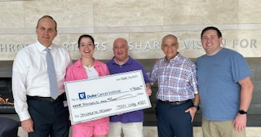
TSDIA Members Kristen & John Zimmer, Frank DeMaria and Don Cimorelli presented the Duke Cancer Institute with the $9,000 raised from our TSDIA Tia DeMaria Memorial Bocce Tournament. Tia was a treasured member of our Lodge along with her love of Bocce. Tia’s spouse Frank and her daughter Kristen have been influential in the growth of our bocce tournament in Tia’s honor. Tia sadly passed away on this date of June 13 in 2023 from pancreatic cancer. Our donation is directed towards pancreatic cancer research and support for patients and their families.

SICILY - Land of Love and Strife – August 3rd
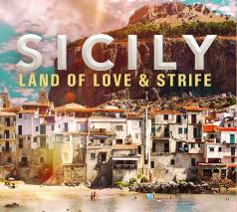
The Triangle Sons and Daughters of Italy present “Sicily: Land of Love & Strife,” a feature-length documentary created to change public perception of Sicily. The film will be shown at the Triangle Theater in Raleigh on Sunday, August 3 at 1:00 pm. Tickets are $10 each. The movie will be hosted by its author and director, Mark Spano, who will answer questions about the movie and Sicily after the documentary. To purchase tickets, go to https://square.link/u/WQ6HoH2g.

The Charit Races of Ancient Rome: It’s Italy’s Palio di Siena!
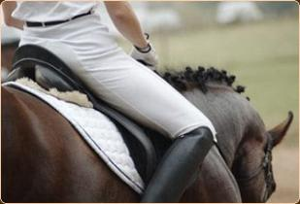
Saturday, August 9, 2025 - 9:00 AM
Triangle Cinema - 9500 Forum Dr, Raleigh, NC 27615
FREE EVENT FOR MEMBERS AND GUESTS WITH BREAKFAST INCLUDED. BRING GUESTS WITH INTEREST IN EXPLORING TSDIA MEMBERSHIP.
It’s time to whet your appetite and introduce you to the coming of our 2nd Annual Siena Palio horse race. If you’re looking for a totally unique, authentic, and breathtaking cultural experience, you just found it! The Triangle Sons and Daughters of Italy is presenting “The Palio of Siena” on Saturday, August 9th at 9:00 am. You’ll enjoy the Palio, which is the most important event of the Sienese town (Tuscany Region) that dates back to the 13th century.
You’ll be joining the Sienese people as they demonstrate their flag throwers, trumpeters, and drummers all dressed in their armor and medieval costumes parading around the Piazza del Campo. They’ll be surrounded by more than 60,000 cheering Contrada (neighborhood) supporters in preparation of the exhilarating and uncontrollable horse race, The Palio. It’s not just a race, but a passion. It’s a chaotic medieval-style horse race that takes place in the Piazza del Campo, Siena’s famous central square. It’s an extremely emotional event that brings the Sienese to tears of joy and despair, despite the race’s macho nature. Absolutely nothing matters more to the Sienese than winning this race for their neighborhood.
Please click on the SignUp Genius Link below to formally register for this event:
https://www.signupgenius.com/go/9040A4DAAAF2EA6FE3-51000253-future#/

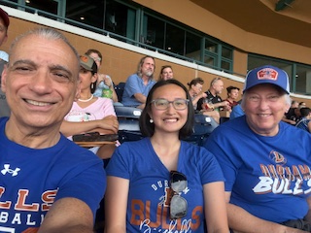
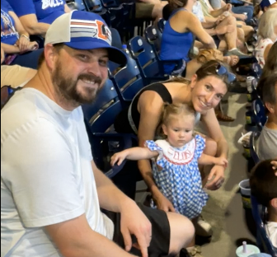
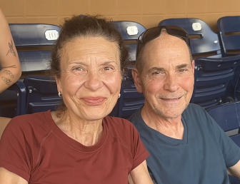
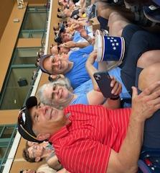
Durham Bulls 2025
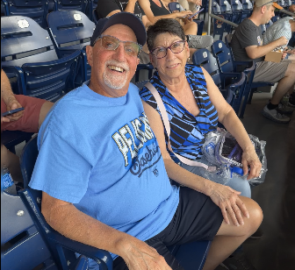
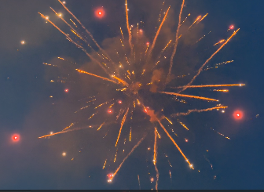


Food & Culture highlights our Italian culture. If you have suggestions we can put it in a future newsletter, please email Nick Verna at nickverna14@gmail.com.

New Members
Please welcome David and Michelle Gifford and their three children, Kayla, Jake and Mia. They heard about us from our Lodge VP Mike D’Amore who is David’s first cousin. Thank you, Mike. David is originally from Rome, NY and Michelle is from Buffalo, NY. David’s heritage is from Bagheria, Palermo, Sicily. He is Senior VP in the field of Commercial Project Management and enjoys sports, music and the beach. Michelle is a Homemaker and enjoys music, the beach and dogs. Kayla recently graduated from University of North Carolina, Wilmington and enjoys business and the beach. Jake attends NC State and enjoys finance, business and hockey. Mia also attends NC State and enjoys cheerleading and the beach. Welcome David and Michelle gifford11@gmail.com, Kayla kaylagifford77@gmail.com, Jake jakegifford93@gmail.com and Mia miagifford77@gmail.com.
Please welcome Cheryl Manasier who heard about us from a friend. She was born in Yonkers, NY and raised in Nanuet, NY. Her heritage is from Naples. She has been in North Carolina for ten years and currently lives in Holly Springs. She is a retired Nurse of 46 years, of which 39 as an ER Nurse. She enjoys cooking and spending time with family. Welcome Cheryl diamondslots@aol.com.
Please welcome Jonathan and Nicole Thompson who heard about us from members Ron and Maureen Warren. Thank you, both. Nicole is originally from Chicago, IL and Jonathan is from Rochester, NY. They relocated to Cary in 2019. Nicole's heritage is from Calabria, Naples, Potenza and Sicily. She does Marketing for Northwestern University and enjoys traveling and baking. Jonathan is a Software Engineer and enjoys Yoga and cooking. They both enjoy hiking adventures with their dog, Winston. Welcome Jonathan thompson.jonm@gmail.com and Nicole nicole.dragonetti@gmail.com.
Please welcome the following members who filed applications during April and May with an effective date of June 1st. By doing this they took advantage of our 15-month membership (June 1 through Aug 31, 2026).

Katherine Jennings originally from Franklin Lakes, NJ and lives in Chapel Hill. Her heritage is from Calitri and she is an artist, writer and former Attorney. Welcome Katherine katjennings84@gmail.com.
Lauren Sisson originally from the Philadelphia, PA area and lives in Holly Springs. Her heritage is from Casalduni and Sciacca, Sicily. She is a Planning Technician for the town of Apex. Welcome Lauren lsisson22@gmail.com.
Cheryl (Cher) Calvalieri originally from Wayne, NJ and lives in Wake Forest. Her heritage is from Fraine and Sicily. She is an Accounting Manager. Welcome Cher dreamerinpurple@yahoo.com.
Salvatore (Sal) and Vanessa Minopoli originally from Great Neck, NY and Belo Horizonte, Brazil. They live in Wake Forest. Sal's heritage is from Torino and he is a retired Baker. Vanessa is a retired Home Health Care Aide and also a Baker. Welcome Sal sv.57@hotmail.com and Vanessa brava.2006@hotmail.com.
Michael (Mike) and Dawn Ricciardi originally from Yonkers, NY and Manchester, CT. Mike's heritage is from Caserta and Dawn is from Udine. Mike is a retired child and adolescent, and forensic Psychiatrist. Dawn is a retired psychotherapist, licensed clinical social worker. They currently live in San Diego, CA and will be relocating to North Carolina. Welcome Mike mtricciardi@cox.net and Dawn dellangelaricciardi@gmail.com.
Ron and Martha Sorrentino who heard about us from member Phil Fantasia. Thank you, Phil. They are originally from Detroit, Michigan and have lived in Cary for 30 years. Ron's heritage is from Palermo, Marsala and Corleone, Sicily. He is retired from Pharmacy Sales and Contracting and enjoys social activities. Martha is a retired Pharmacist and enjoys quilting, reading, playing cards and social activities. Welcome Ron ronald0414@gmail.com and Martha martha.sorrentino@gmail.com.
Robert Munno who is the husband of member Debora Munno. He is originally from Staten Island, NY. Robert's heritage is from Naples and he lives in Clayton. He is retired from the New York City Department of Sanitation and enjoys classic cars and Carolina Hurricane hockey. Welcome Robert munnorobert@gmail.com.
Lizmarie De Biaggi who is the wife of member Andrey De Biaggi. She is originally from Puerto Rico and lives in Cary. She is an Architect and enjoys Pilates and the beach. Welcome Lizmarie lizmarier@hotmail.com.
Please welcome Trish Legarth who heard about us from member Noelle Marino. Thank you, Noelle. Trish is originally from Cleveland, Ohio. She was stationed at Seymour Johnson AFB, Goldsboro as a Registered Nurse and after retirement in 1999 settled in North Carolina. She lives in Apex. Her heritage is from Capizzi, Sicily and she enjoys traveling, reading and woodworking. Welcome Trish plegarth@gmail.com.

Member Business Spotlight
Each month we will spotlight a member owned business.
Zebra Print Solutions



We would like to extend our sincere thanks to Zebra Print Solutions and the DiLeonardo’s for providing our organization with our printing needs such as business cards and member cards. They have been supporting us since our early days in Raleigh. Their outstanding service and meticulous attention to detail, innovative processes, and consistent delivery have made a meaningful impact on their client’s success. We truly value their partnership. Simply stated, for businesses that depend on flawless printing and fulfillment for their success, they are the right choice.
www.zebraprintsolutions.com

Eating in Italy like a local citizen: tips for foreigners
https://lifeinitaly.com/eating-in-italy-like-a-local-citizen/
Unfortunately, foreigners often come to Italy with the myth that pizza and pasta are the only gastronomic excellences, overlooking what it truly means to be eating in Italy like a citizen. In this article I explain how to find fresh goods on your own and experience village festivals like a true insider, going beyond the very delicious—but unfortunately the only known—Italian pizza and pasta.
The role of the market in an Italian’s daily life
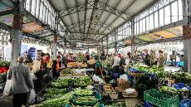
In cities, markets open early in the morning, while in small villages farmers arrive with baskets of fruit, vegetables, and cheeses freshly harvested or produced. Participating in a market can be an excellent starting point if you are a foreigner, to get first-hand experience of culinary tradition and eat like a local citizen.
Below I list 5 perfect markets to understand how this world works:
Testaccio (Rome)
Located in the heart of the Testaccio neighborhood, this market is a concentration of Lazio producers. In the morning, among stalls of vegetables and cheese stands like Roman ricotta or Amatrice pecorino, you breathe in the popular soul of the Capital. Don’t miss the typical rotisseries and historic fishmongers.
Mercato delle Erbe (Bologna)
Situated in the historic center, this covered space hosts Emilian producers and food artisans. Here you find Mora Romagnola cured meats, traditional mortadella, and vegetables. Between one row and another, look for the “mastì” corner: small artisanal dairies that offer tastings of raw-milk cheeses.
Mercato di Sant’Agata de’ Goti (Campania)
Set up on Saturday morning in the main square, it sees farmers from Sannio and Alta Irpinia offering Piennolo cherry tomatoes, Silana provola, and mountain olives. Here, Saturday means animation: tastings of fresh mozzarella, advice on olive harvesting, and the chance to discover typical local vegetable varieties, such as the Roccaraso bean.
Porta Palazzo (Turin)
One of the largest open-air markets in Europe, spread over several squares. In addition to fruits and vegetables, exotic spice stalls and local fishmongers stand out. To feel like a true Turinese, explore the section dedicated to “forgotten products”: ancient Piedmontese apple varieties, Montoro ramata onions, and wines from small winemakers.
Mercato Coperto San Lorenzo (Florence)
A stone’s throw from the Duomo, it offers quality Tuscan productions: lampredotto, finocchiona, and extra virgin oil from San Casciano. The lampredotto stall is unmissable for a typical snack, while you can talk with cheese and cured meat producers to hear stories of transhumant sheep and pigs raised in the mountains.

Castel Gandolfo: the Pope’s summer retreat
https://italoamericano.org/castel-gandolfo/
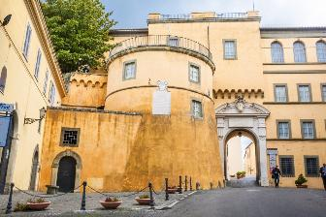Castel Gandolfo is a small but historically rich town located in the Alban Hills, about 25 kilometers (just over 15 miles) southeast of Rome, overlooking the waters of Lake Albano. Despite its size, this village is internationally known as the traditional summer residence of the Popes and for its stunning natural setting, which has made it a favored retreat for centuries. Perched on the rim of an ancient volcanic crater, Castel Gandolfo offers visitors amazing views, a relaxing atmosphere, and a deep connection to Italy’s religious and cultural history.
The origins of Castel Gandolfo date back to ancient Roman times: the area around Lake Albano was once the site of Alba Longa, a legendary city said to have been founded by Ascanius, the son of Aeneas. According to tradition, Alba Longa was the mother city of Rome, and its destruction eventually gave rise to the power of the Eternal City. During the imperial era, the Roman aristocracy built luxurious villas in the area to escape the heat of the city, taking advantage of the fresh air and peaceful setting. Emperor Domitian, in particular, established an imposing residence on the shores of the lake, remnants of which can still be visited today.

The name “Castel Gandolfo” is believed to derive from the Gandolfi family, a noble Lombard lineage who held feudal control over the area during the Middle Ages. They built a fortress here that eventually gave the town its name, with “Castel” referring to the castle or fortified residence. Over the centuries, the town passed through the hands of various powerful families and church authorities until 1596, when Pope Clement VIII acquired the property for the Papal States. In the 17th century, Pope Urban VIII commissioned the construction of the Apostolic Palace, which became the official summer residence of the Pope.
Castel Gandolfo remained the papal summer retreat for over four centuries. Popes would stay here during the hottest months of the year, enjoying the cool lake breeze and serene environment. The Apostolic Palace, while closed to the public for many years, was opened as a museum by Pope Francis in 2016, offering visitors the rare opportunity to explore papal apartments, gardens, and ecclesiastical treasures. The adjoining Barberini Gardens, which stretch across the ancient ruins of Domitian’s villa, are among the most enchanting attractions of the town, blending archaeological heritage with manicured Renaissance design.
Apart from its papal associations, Castel Gandolfo offers much to explore within its historic center: the Church of San Tommaso da Villanova, designed by Gian Lorenzo Bernini in the 17th century, dominates the central square with its elegant Baroque architecture, while narrow streets run through the village, lined with small artisan shops, traditional cafés, and panoramic terraces that look out over Lake Albano. The lake itself is popular for rowing, walking, and picnicking, and its circular shape hints at its volcanic origins.
Castel Gandolfo is also known for its food, which reflects the rustic and hearty traditions of the Castelli Romani area. Local specialties include porchetta (herb-stuffed roast pork), coppiette (spiced dried meat), and panzanella, a refreshing bread salad. Wines from the nearby vineyards, especially Frascati, are a perfect match for these dishes.
During the summer months, the town hosts festivals and open-air events, including food tastings and concerts, that bring together locals and visitors in celebration of tradition and conviviality.
One lesser-known curiosity is that Castel Gandolfo technically served as a refuge for Popes during times of political crisis: during World War II, Pope Pius XII sheltered hundreds of displaced persons within the palace walls, turning the papal estate into a haven for civilians fleeing the bombings in Rome.
Today, Castel Gandolfo remains a place layered with history, and where visitors are always close to beauty. Its quietness and cultural richness continue to charm travelers who, just like the Romans of old, seek peace and relax just a stone’s throw away from the city.

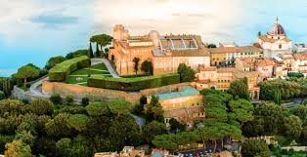
Thanks to Netflix's 'Nonnas,' Italian grandmas are having their moment
https://www.northjersey.com/story/opinion/2025/05/23/nonnas-netflix-italian-grandmas-are-having-their-moment-opinion/83795876007/
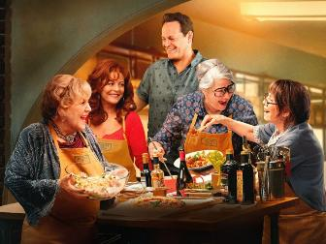The Netflix film "Nonnas" features Italian grandmothers and has become a streaming hit. The film is based on a real Staten Island restaurant where grandmothers from around the world cook. The popularity of "Nonnas" reflects a broader cultural fascination with Italian grandmothers, as seen in other media like "Pasta Grannies" and "The Golden Girls."
This fascination stems from their simple truths, connection to roots and resilience. When hot cultural trends come to mind, the frumpy, feisty Italian grandmothers of my childhood aren’t usually at the top of the list. And yet "Nonnas," the breakaway Netflix film starring these very kinds of characters, has been the No. 1 film in the rankings and viewed more than 20 million times since its release, continuing to make headlines and populating social media faster than a Real Housewife's tabloid gaffe.
The heartwarming movie is about a young Italian American man named Joe Scaravella who is mourning the recent loss of his mother, a major force in his life. Joe, played by Vince Vaughn, seems perpetually lost after his mother’s death. But when he comes across a dilapidated storefront, he has a vision and takes a leap of faith, hoping to open a restaurant that will resurrect the joys of his childhood through the cooking of his mother and grandmother. Viewers soon learn that sumptuous dishes like caponata and “Sunday sauce” come with a heavy side of wisdom, perseverance and old-world love. These messages are delivered by the four nonnas — Italian for grandmothers — Joe hires to do the cooking. It sounds like a smart cinematic twist, but in this case it’s an example of art mirroring real life. Joe Scaravella and his Enoteca Maria on Staten Island are the basis for the film. Since 2007, the nonnas there have been cooking up pots of delectable treasures, and today the chefs include nonnas from all around the world doling out their best dishes.
'Nonnas' taps into something deep in our cultural fabric. Some would be quick to argue that the film is just another addition to the collection of feel-good family movies that populate our streaming services and movie theaters each spring. But "Nonnas “taps into something deeper in our cultural fabric, something that predates this current iteration and mines the longstanding trope of Southern-Europeans-teach-the-world-a-lesson about family, life and love.
That magical interaction with Italy likely dates to the 17th-century establishment of the Grand Tour, a trek made by upper-class Englishmen, and later Gilded Age Americans, mainly to places in Italy to experience the antiquities, art and hidden hedonism. The model most familiar to us — where Italians possess and give the transformative power to illuminate life’s paths — is found in early-20th-century novels such as E.M. Forster’s "Where Angels Fear to Tread “and Elizabeth von Arnim’s "The Enchanted April."
Joe (Vince Vaughn) recruits a bunch of Italian grandmothers (Lorraine Bracco, Talia Shire and Brenda Vaccaro) to be the chefs of his new restaurant in "Nonnas." In these tales, the cold, unfeeling WASPs are introduced to the alluring bounty of Italy — with its lyrical language, music, food and passionate people. They enter into relationships with Italians who unmoor their social sensibilities and awaken their intellectual curiosity and libidos, chipping away at their stunted veneers. They are forever changed — some tragically — and are unable to go back to the life they previously knew, their newfound enlightenment forging a path to a more authentic future.
At the heart of these performances, and the archetypes they represent, is the abiding sense that somehow the Italians, for all of their drama and disorder, hold secrets for living a life grounded in “what really matters.”
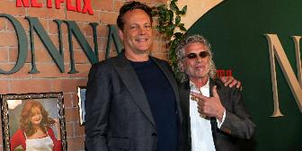
The original Enoteca Maria, on which the film is based, opened in 2007 and still operates today on Staten Island, with Nonnas bringing a huge amount of publicity and attention to the establishment.
Cala Goloritzé, the best beach in the world is in Sardinia
https://www.wetheitalians.com/single_post/cala-goloritze-best-beach-world-sardinia
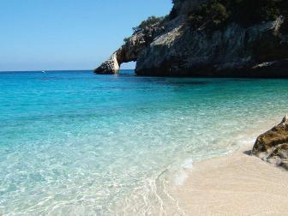Italy reclaims the title of having the most beautiful beach in the world. At least according to the website 'The World's 50 Best Beaches,' which has been ranking the best spots around the globe for years. Cala Goloritzé, with its pebbles in front of an unparalleled stretch of crystal-clear water, has secured the top spot, making Sardinia one of the most sought-after destinations for next summer.
Another Sardinian representative also made the list of the top 50 beaches: La Pelosa in Stintino, another natural masterpiece in the province of Sassari. This ranking is the result "of countless days spent by our judges, Beach Ambassadors, and the World's 50 Beaches team exploring beaches in every corner of the planet," according to the website.

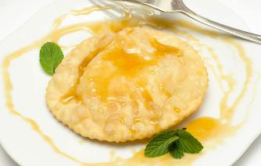
Seada
These deep-fried Sardinian pastries combine wheat or semolina dough with a slightly savory cheese filling. Sebadas are typically round and come filled with the sweet and aromatic young Pecorino Sardo cheese. Primarily a frugal and rustic dish, especially beloved by shepherds, sebadas were originally a savory dish, but nowadays they represent a classic Sardinian dessert.
They are traditionally served drizzled with honey and dusted with sugar.
For the pastry
8 3/4 oz of semolina flour, plus extra for dusting
1 1/4 oz of lard, at room temperature (or use olive oil)
4 1/4 fl oz of warm water, or as needed
For the filling
8 3/4 oz of young Pecorino cheese, shredded
1 unwaxed lemon, zested
To serve
sunflower oil, or olive oil, for frying
honey, for drizzling (warmed)
Directions
In a large bowl, make a dough by combining the flour with the lard and the water – add it bit by bit – until it reaches a workable, elastic texture. Knead the dough until you have a smooth ball. Wrap it in cling film and let it rest for at least 30 minutes
Make the filling by melting the cheese in a small saucepan set over a low heat. (Add a tablespoon of water if you see that the cheese has a hard time melting.) Once melted, stir in the lemon zest, then pour it out onto a large chopping board or a baking tray lined with parchment. Spread it out to about ½ cm thick using a spatula; leave it to cool and set completely, then cut out 12 circles using a 6cm cookie or round pasta cutter (or, alternatively, a cup of the same size)
Dust a working surface with semolina flour. Roll out the dough to about 2mm thickness. Cut out 24 7cm wide circles. Place a round of cheese over a round of pastry, then top it with a second round of pastry and press the edges to seal the seada. (You can use a fork, too.) Repeat with the remaining cheese and pastry
Fill ¾ of a high-edged skillet with oil and set over a medium heat. As soon as the oil reaches 180°C, fry the seadas in batches until deeply golden on both sides. Drain with a slotted spoon and transfer to a platter cover with kitchen paper
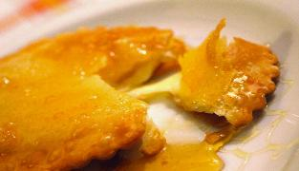
Drizzle the piping-hot seadas with warm honey and serve right away

Pasta Salad with Sun-Dried Tomatoes and Artichokes
Servings: 6
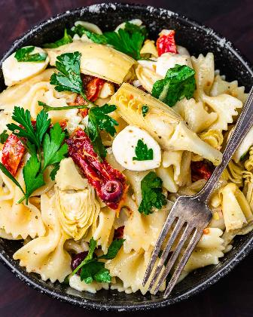Ingredients
1 pound bow tie pasta or any bite size pasta you like
8 oz. mozzarella balls halved, or cubed block mozzarella
1/2 cup Gaeta olives pitted and sliced, sub Kalamata
2 15 ounce can artichoke hearts drained and quartered
1 12 oz. jar sun-dried tomatoes drained (save liquid), sliced
1/2 cup chopped Italian flat-leaf parsley
For the Italian dressing
1/4 cup red wine vinegar
1/4 cup lemon juice
3/4 cup sun dried tomato oil use extra virgin to make up the difference
2 teaspoons Dijon mustard
1/4 cup grated Pecorino Romano
2 teaspoons dried oregano
1/4 teaspoon crushed hot red pepper flakes
2 cloves garlic paste
salt and pepper to taste
Instructions
For the Italian dressing

Combine all of the dressing ingredients and whisk together until emulsified. Alternatively, use a food processor, blender, or immersion blender. Taste test the dressing and season with salt and pepper if required.
For the salad
Cook pasta in salted water until al dente, then drain and rinse until cool.
In a large bowl, mix together the pasta, mozzarella, olives, parsley, artichoke hearts, and sun dried tomatoes.
Pour 3/4 of the dressing on top of the pasta and mix well. If you need more dressing, add a bit at a time to get the consistency just right. The remaining dressing can be served on the side or saved in the fridge for a green salad during the week.
The pasta salad flavor will taste much better if chilled for at least an hour before serving. Enjoy!
Notes
The sun-dried tomato oil is great for the dressing. Use extra virgin olive oil to make up the difference if required.
Chilling the pasta salad for a few hours before serving really amps up the flavor.
Any pasta salad can be rejuvenated by mixing in a bit more oil and vinegar right before serving.
Leftovers can be saved for up to 3 days.
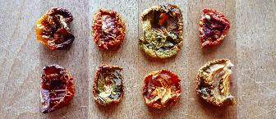
How are Sun-dried Tomatoes made?
Sun-dried tomatoes are made by reducing the moisture content of tomatoes, either through natural sun-drying or by using an oven or dehydrator. The process concentrates the tomato's flavor, resulting in a sweet and tangy ingredient popular in various dishes.
- Preparation: Tomatoes are washed, halved, and sometimes lightly salted.
- Drying: The tomatoes are placed cut-side up on a baking sheet lined with parchment paper and baked at a low temperature (around 200-250°F) for several hours.
- Monitoring: The oven is checked periodically to prevent burning or over-drying.
- Completion: The tomatoes are dried when they reach a leathery, pliable texture.

Pasta alla Norcina
www.sipandfeast.com/pasta-alla-norcina/
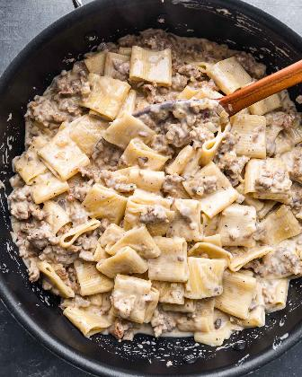
Pasta alla Norcina is a creamy pasta full of the comforting flavors of pork sausage, white wine, Pecorino Romano, and just a touch of nutmeg. The velvety texture of the sauce pairs perfectly with the al dente pasta and crumbled sausage. Relatively simple to make, this dish is perfect for a weeknight when you want just a bit of decadence.
Pasta alla Norcina may be the most underrated pasta EVER.
Underrated because with one exception, I have not seen this on the menu of Italian restaurants here in New York, and I think it damn well deserves to be! 😉
Perhaps that is because this dish hails from the city of Norcia in Italy’s Umbria region, where most of the Italian immigrants who came to the US (my ancestors included) were from Southern Italy and Sicily.
T traditionally, pasta alla Norcina is made using a pork sausage made in Norcia using a combination of white wine and nutmeg. A bit different from the typical fennel pork sausage available here in New York.
In addition to Norcia sausage, the dish is also typically topped with a shaving of black truffles, which are also foraged in Norcia.
Servings: 6
Ingredients
1 pound rigatoni or other tubular pasta
8 ounces baby Bella mushrooms diced
1 pound bulk mild Italian sausage
1/4 cup olive oil
1 small onion diced
3 cloves garlic
1/2 cup dry white wine
1 1/2 cups heavy cream
2 cups reserved pasta water will not need it all
1 pinch nutmeg
3/4 cup Pecorino Romano grated
salt and pepper to taste
Instructions
Bring a large pot of salted (2 tablespoons kosher salt) water to boil.
Heat a large pan to medium heat then add in the olive oil and sausage. Brown the sausage (about 5-7 minutes) then make some room in the pan and add the mushrooms and continue to cook until they brown as well.
Once the sausage and mushrooms are brown add the onion and garlic. After 2 minutes remove the garlic from the pan and discard. Continue cooking for a few more minutes until the onions are soft.
Turn heat to medium-high and add the wine. Cook for a minute to reduce the wine by about half. Scrape the bottom of the pan with a wooden spoon to remove all the brown bits. At this time begin cooking pasta to a bit less than al dente.
Add the cream and bring sauce to a simmer while stirring. Once simmering turn the heat down to low.
Once pasta is almost al dente add it to the sauce and mix to coat. Turn heat to medium. Add a bit of pasta water if needed to loosen things up. Continue to cook, stirring frequently, until the pasta is perfectly al dente.
Turn the heat off and remove the pan from the heat. Add the Pecorino, mix well, then taste test. Season with a good amount of black pepper, a pinch of nutmeg, and salt to taste. Serve with grated Pecorino. Enjoy!
Notes
- Makes 4 very large servings or 6 normal size ones.
- If the pasta dries out at all just add a touch of the reserved pasta water to loosen it up and mix well before serving.
- Serve with extra grated Pecorino Romano cheese and nutmeg. Nutmeg can be overpowering so it’s best to let the individual add more if they like.
- Leftovers can be saved for up to 3 days and can be reheated on the stovetop or the microwave.

