Scopa Rules

tial setting
- The dealer deals out three cards to each player, one card at a time.
- The dealer places four cards face up on the table (only at the game's start).
- If the initial table cards include three or four kings, the cards are re-shuffled.

The game
- The player can place a card on the table, or play a card to capture one or more cards.
- The player can capture a card if:

  - it has the same value on the table
  - by matching his card to the sum of the values of two or more cards on the table.
- The captured cards are removed and placed face down in a pile in front of the player
- If by capturing, all cards were removed from the table, then this is called a scopa, and an additional point is awarded
- If you can capture, you must
- If played card may capture either a single or multiple cards, the player is forced to capture only the single card.
- After the final card of the final hand of the round has played, the player who most recently captured is awarded any remaining cards on the table

Scoring
- Players get one point for each "scopa".
- Other points go to who:

  - captures the greatest number of cards.
  - captures the greatest number of cards in the suit of coins.
  - captures the seven of coins ("sette bello").
  - obtains the highest "prime" ("primiera").
- If two or more teams or players capture the same number of cards, same number of coin cards, or the same prime value, no point is awarded for that result, e.g. if both Team 1 and Team 2 capture 20 cards total, neither gets a point for the most cards.
- The "prime" for each team is determined by selecting the team's "best" card in each of the four suits, and totaling those four cards' point values. When calculating the prime, a separate point scale is used. The player with the highest number of points using this separate point scale gets one point toward the game score. The most common version of the separate scale is:
  - Seven (sette) = 21 points,
  - Six (sei) = 18 points,
  - Ace (asso) = 16 points,
  - Five (cinque) = 15 points,
  - Four (quattro) = 14 points,
  - Three (tre) = 13 points,
  - Two (due) = 12 points,
  - King (re) = 10 points,
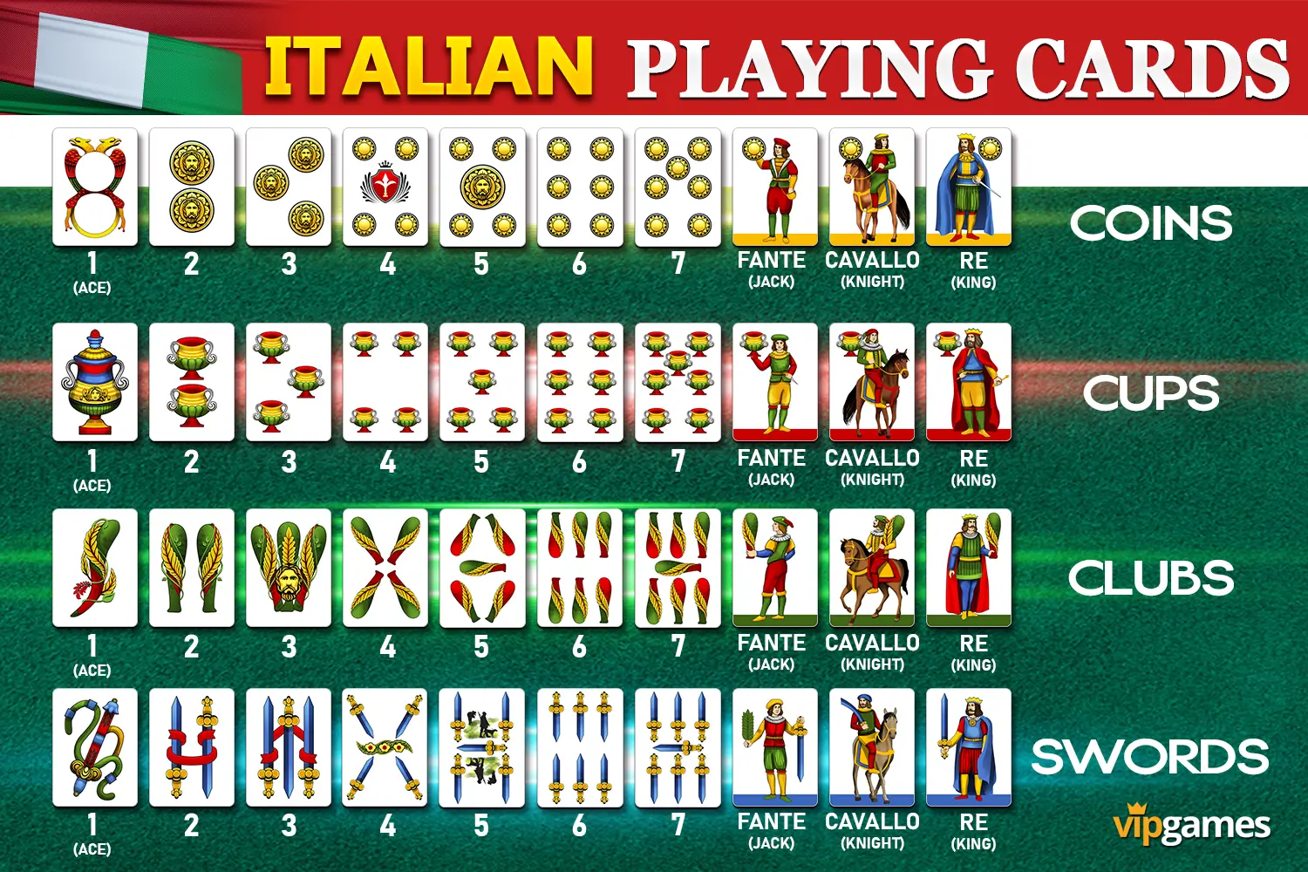
- The game is played until one player has at least 11 points.
8 9 10
S

